Hosting a Static Website using Amazon S3

My research into Amazon S3 buckets lead me to discover that buckets could be used to host static webpages. I wanted to learn more and decided to research more into the subject matter. I created a static website using an Amazon S3 bucket and wanted to replicate the process in a tutorial guide for others to use.

### **Prerequisites**

Before getting started, there are a few perquisites you will need to have:

* An Amazon AWS account and have an Amazon S3 Bucket already created. For more information on creating a bucket, please see [Creating a bucket](https://docs.aws.amazon.com/AmazonS3/latest/userguide/create-bucket-overview.html).
* An index document that is an HTML file. If you do not have an index.html file, you can use the following HTML to create one:

# <!doctype html> <html> <head> <title>This is the Title of the Webpage</title> </head> <body> <h1>This is an example header.</h1> <p>This is an example paragraph.</p> </body> </html>

### **Bucket Setup**

Once you’ve logged into your Amazon AWS account, navigate to the [Amazon S3 console](https://s3.console.aws.amazon.com/s3/). Here you will see a listing of your buckets. Click on the bucket you want hosting your static website.

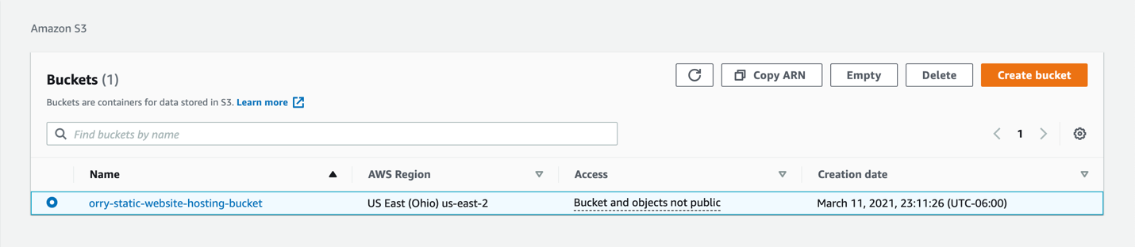

After selecting your bucket, you will be taken to the bucket overview page. You will see a row of tabs below your bucket name. Click on the **Properties** tab.

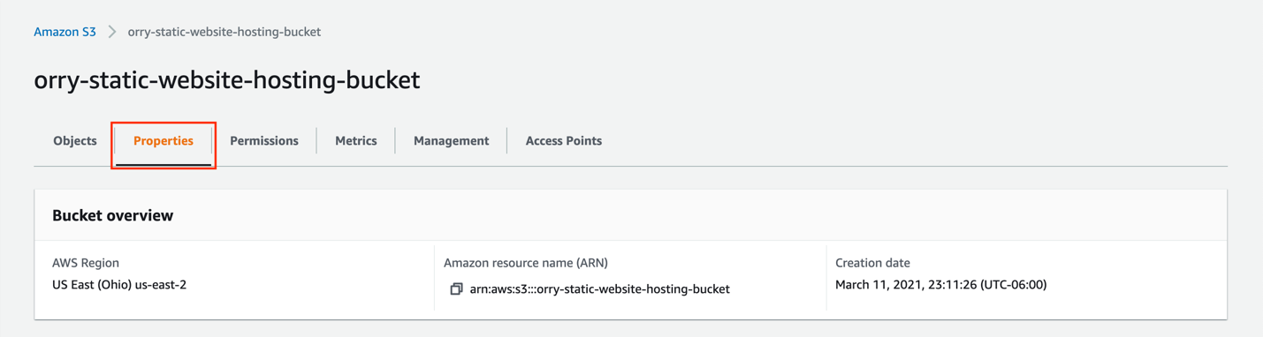

The properties section is where you are going to enable your bucket to host static webpages and determine the website’s index page. Scroll down to the **Static website hosting** area and select **Edit** in the upper, righthand corner.

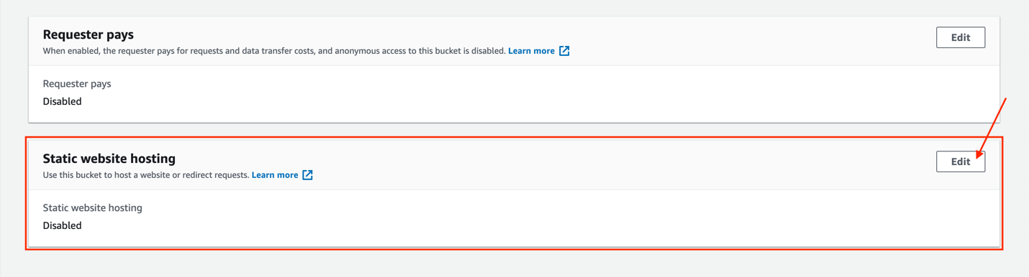

On the edit page, there are a few selections to choose from. Under **Static website hosting**, choose **Enable**. This allows your bucket to begin hosting websites. Under **Hosting type**, choose **Host a static website**. The hosting type determines how you can direct users to your website.

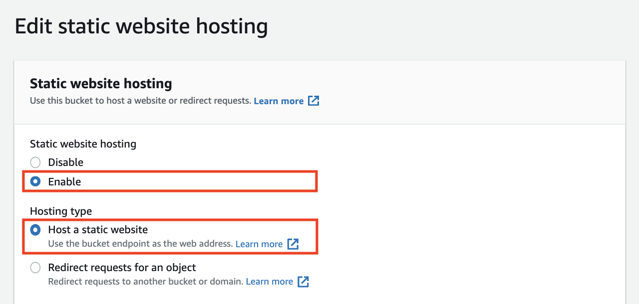

Note

Under Hosting type, the Redirect requests for an object option will allow your bucket to redirect requests for an object to another object or URL. This option can be used when you do not want your webpage to be static or want to change the URL address of your website. For more information on webpage redirect, please see [(Optional) Configuring a webpage redirect](https://docs.aws.amazon.com/AmazonS3/latest/userguide/how-to-page-redirect.html).

Under **Index document**, enter the exact name of your index document file name in the dialog box, then choose **Save Changes**.

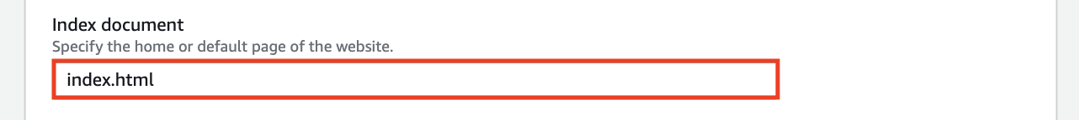

Note

The index document name that you enter in the Static website hosting dialog box will need to exactly match the document file name you upload for your webpage later on. The index document name is case sensitive. For example, if you enter index.html in the Index document dialog box, then your index document file name must also be index.html and not INDEX.html.

### **Uploading a File**

Now that you have setup your bucket for static website hosting, you need to upload your index document. Navigate to your Amazon S3 console, and select the bucket you chose to statically host websites from.

Under the **Objects** tab, choose **Upload** in the upper, left-hand corner or center of the console.

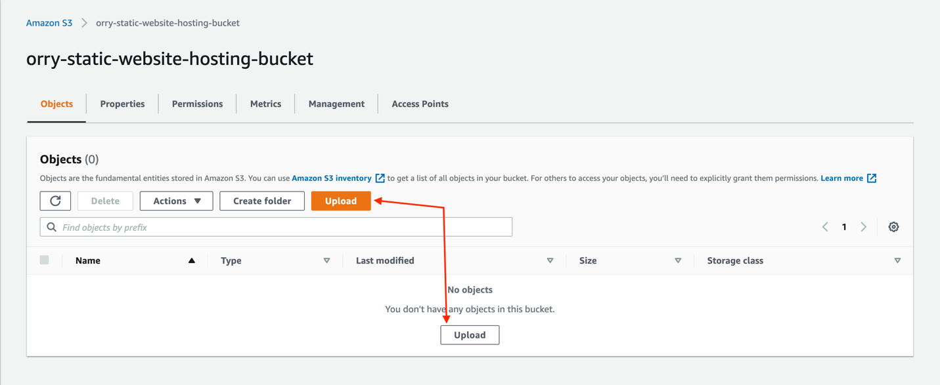

On the Upload page, drag and drop your index document file in the designated drop area, or Choose **Add Files** in the upper, righthand corner.

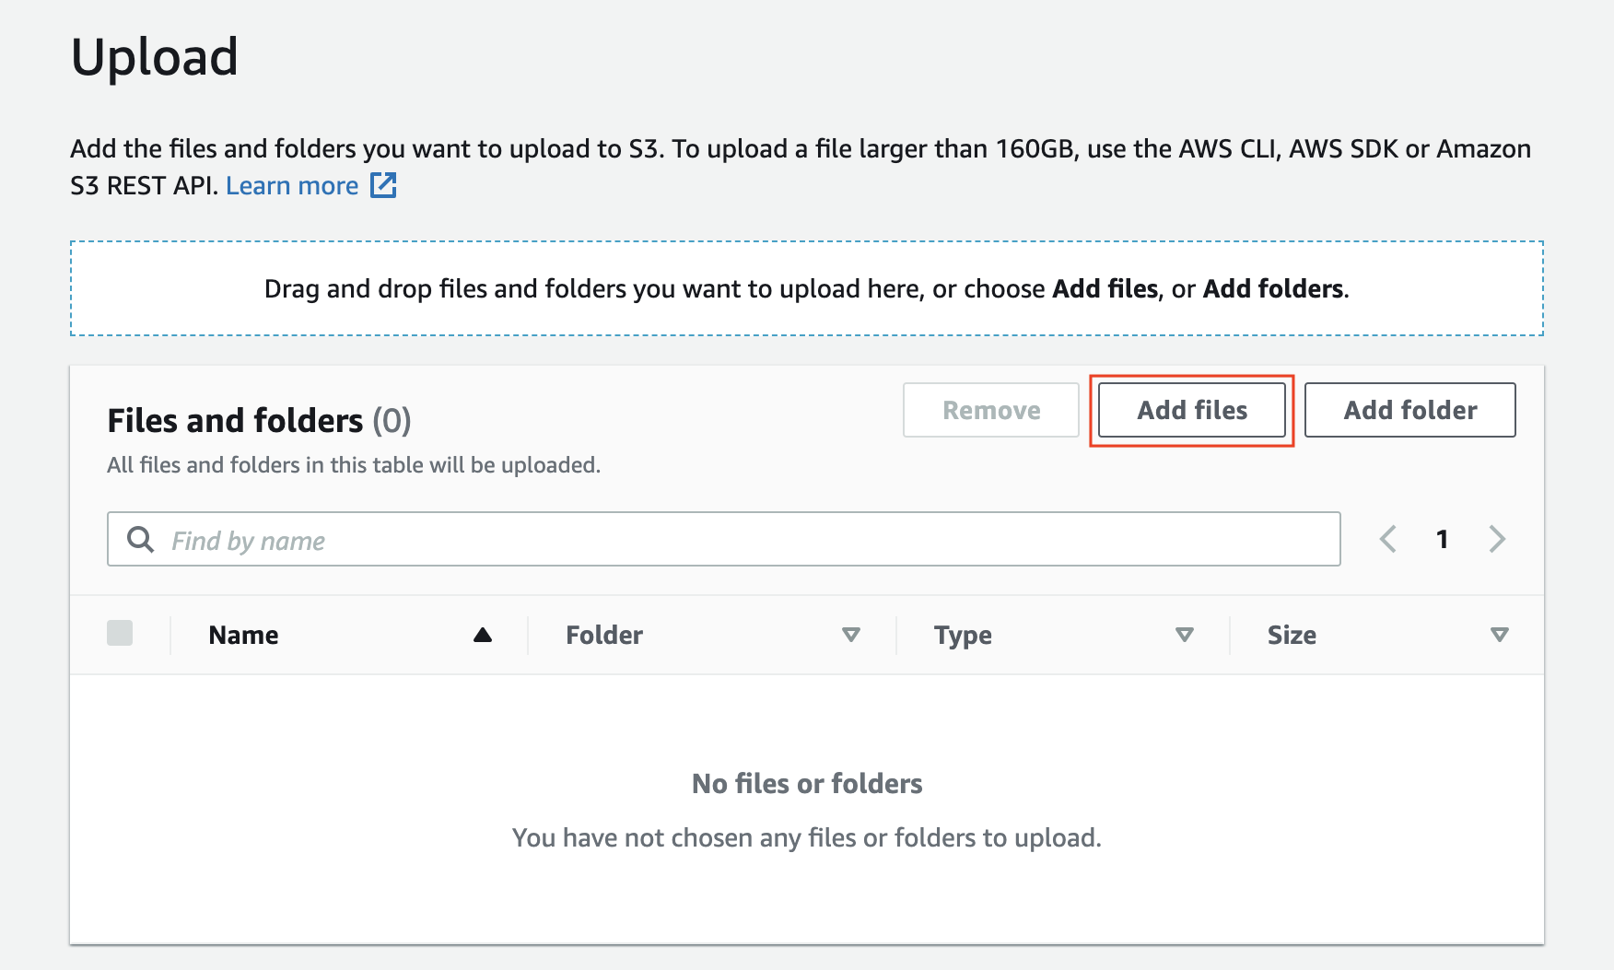

Note

Remember that the index document file name needs to exactly match the index document name you enter in the Static website hosting dialog box.

Select your file and Choose **Upload**. This will upload your file to your S3 bucket.  
  
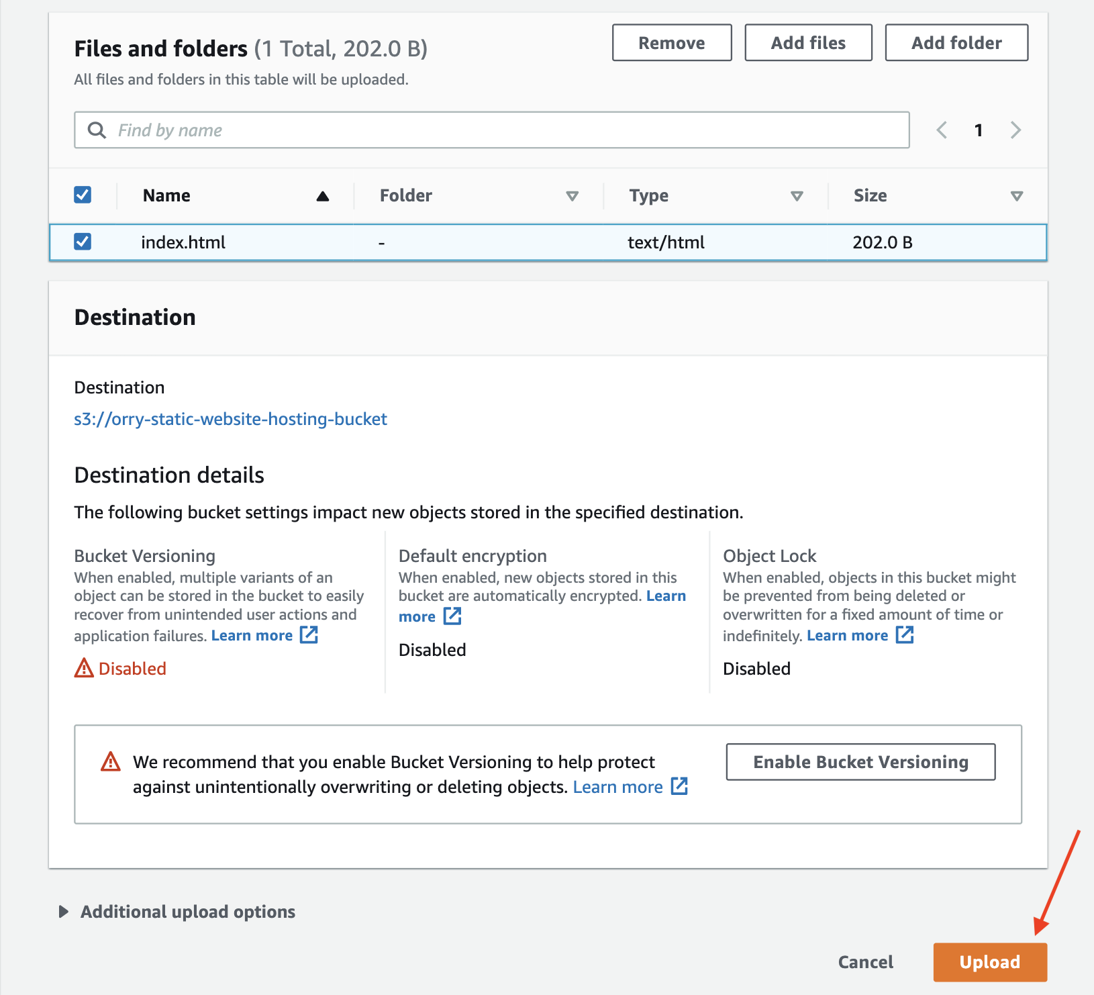

You will receive a success message when your file is uploaded.

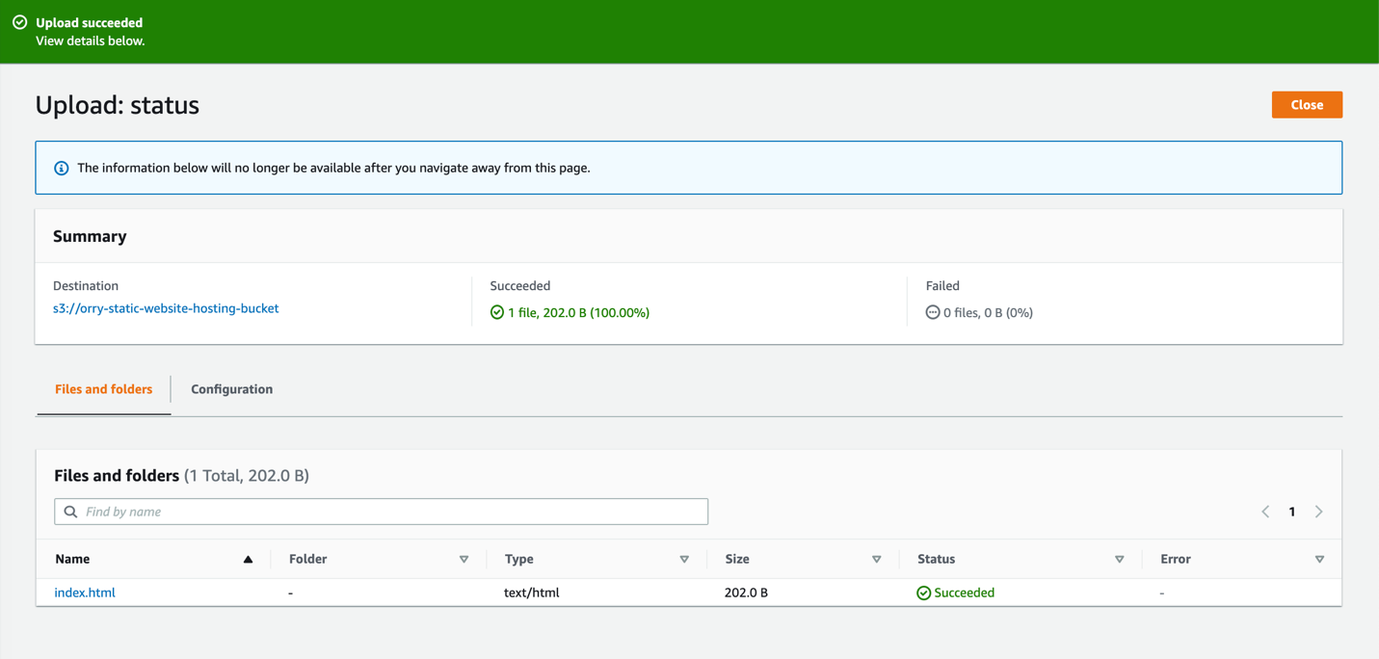

### **Public Access Settings**

For users to access your website, you will need to make your S3 bucket and your index document publicly readable. To do so, you will need to edit the S3 Block Public Access settings for your bucket and make your index document public. Navigate to your [Amazon S3 console](https://s3.console.aws.amazon.com/s3/), select your bucket, and select the **Permissions** tab.

Under the **Block public access (bucket settings)** section, choose **Edit**.

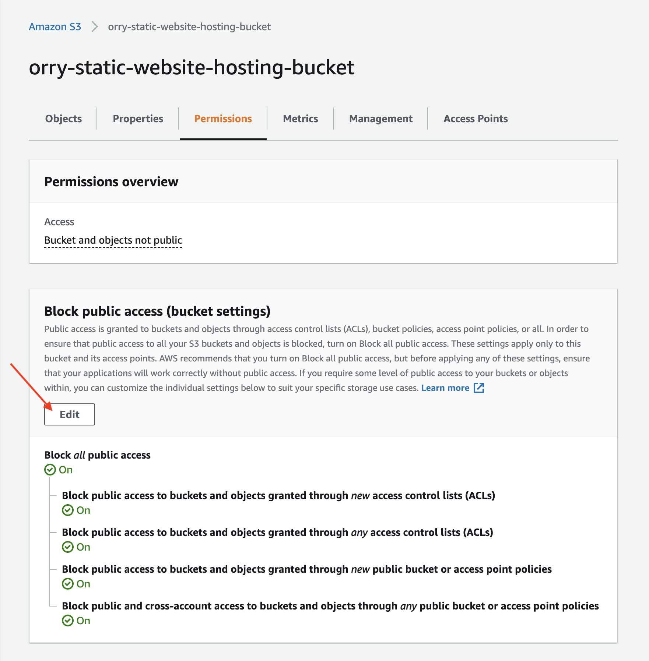

Uncheck the box for **Block all public access**, and each box underneath, then choose **Save changes**.

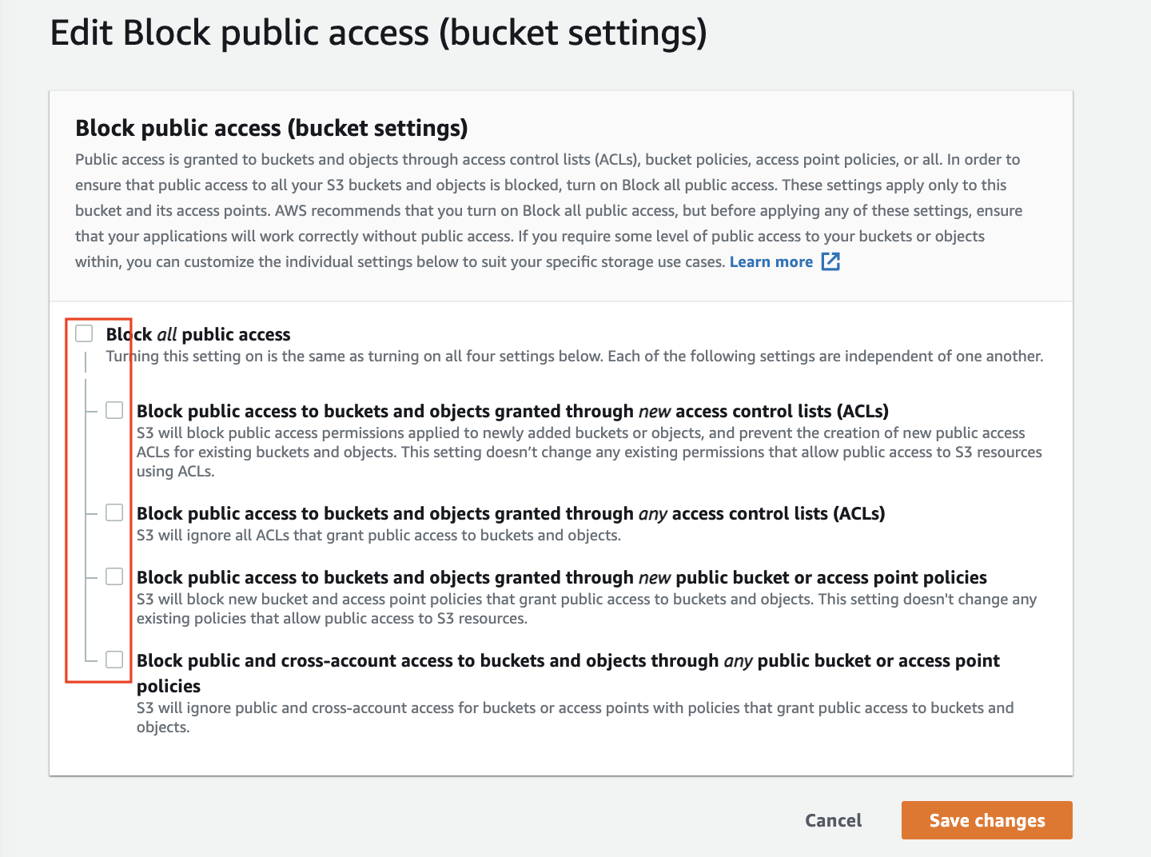

Type “confirm” in the dialog box, then choose **Confirm**.

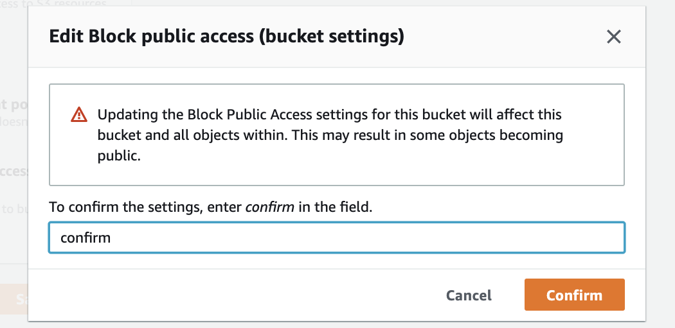

You will receive a success message after updating your Block Public Access settings.

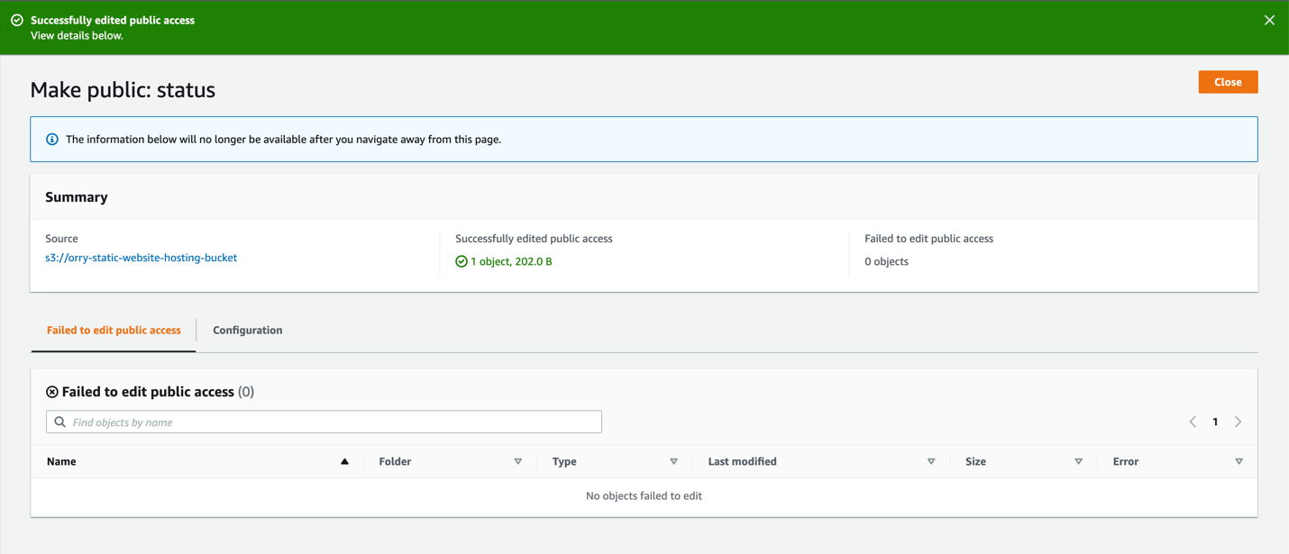

### **Make Website Public**

Navigate back to your bucket. Select you index document file and click on the **Actions** dropdown. Under Actions, choose **Make public**.

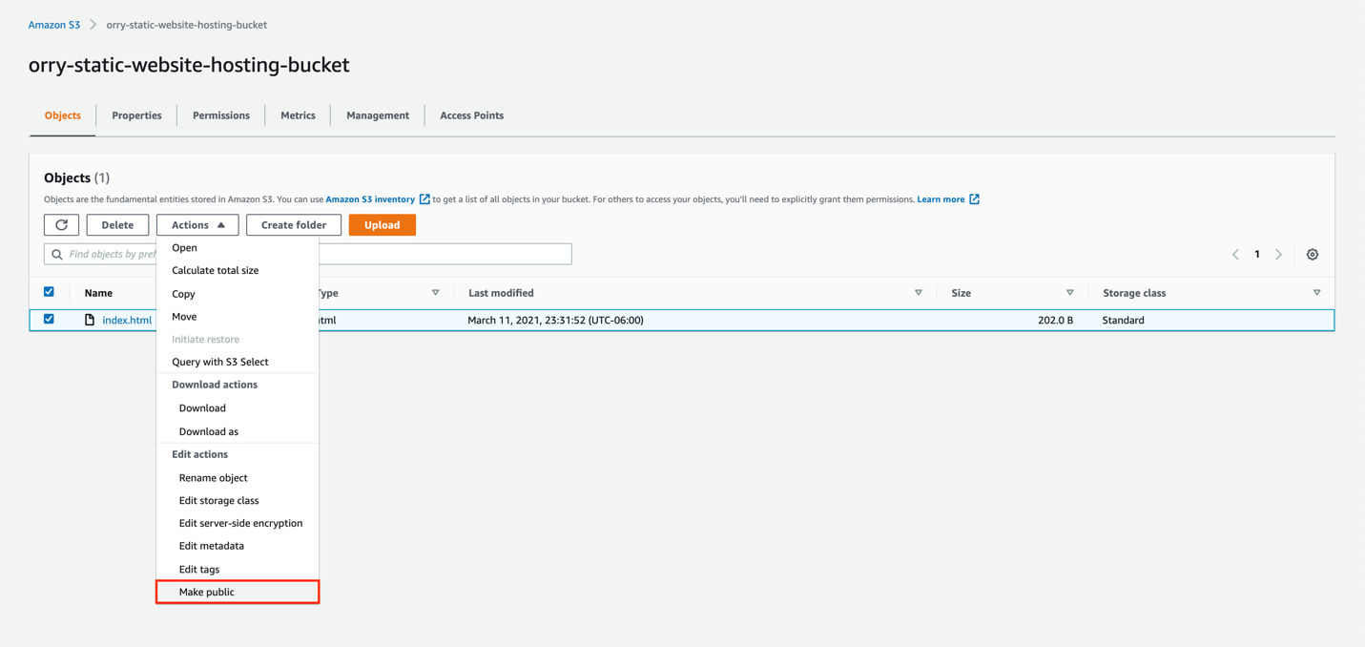

After reviewing and verifying the information presented, choose **Make public**.

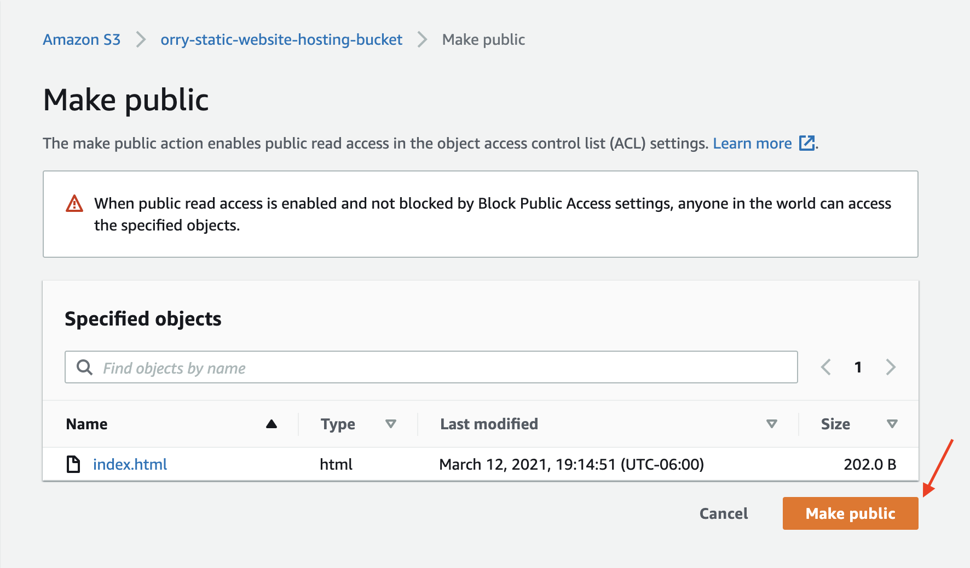

You will receive a success message when your file is made public.

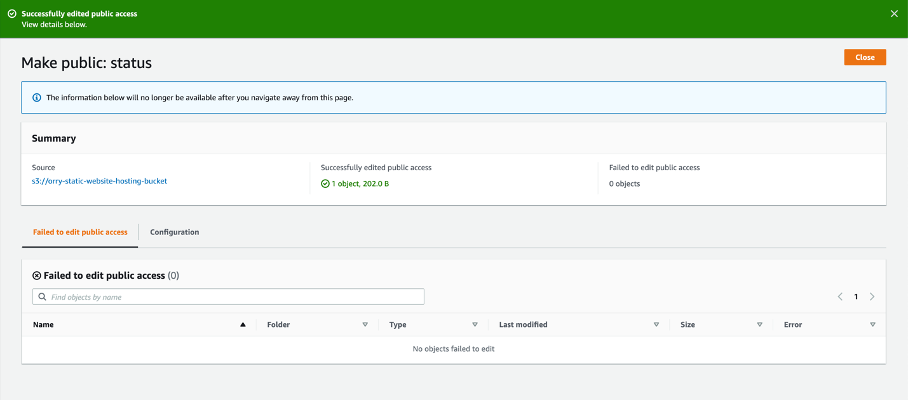

To get your website URL, navigate back to your bucket. Select the Properties tab, and under the Static website hosting area, you will find your website URL under **Bucket website endpoint**. Navigate to the URL presented.

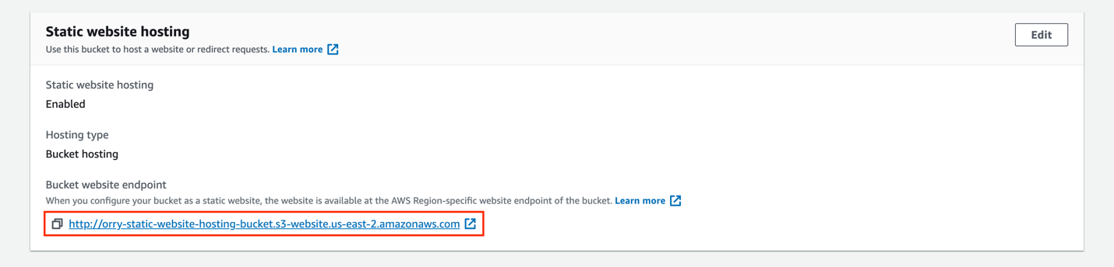

Congratulations! You now have a publicly accessible static website.

